# M1 Info – Technical English – Session 3 – Security

## Starter - Speaking

1. What would you recommend to users wishing more secure passwords? Explain and give examples.
2. Read the comic about passwords. What do you think of the point that is made, and of the suggested solution?
3. Could you define network security?
4. List the various forms of threats to networks.
5. Match the malware with the damage:

|  |  |
| --- | --- |
| 1. Virus | a. collects and sends private information from the infected computer to a third party |
| 2. Spyware | b. an undesirable program which can replicate itself across a network |
| 3. Trojan horse | c. allows a hacker to access private information when they wish |
| 4. Keystroke logger or keylogger | d. a program which adds itself to an executable file, and can cause considerable damage to the data on the infected computer |
| 5. Worm | e. records characters that are typed into a computer |

## Listening / Video - Bots, viruses, spyware and malware

1. What is the relative importance of viruses today compared to other forms of threats?
2. What mistake do we make when considering these threats?
3. How would you compare viruses and bots?
4. What term is used to refer to viruses? Why?
5. Give two things bots allow hackers to do.
6. According to the FBI, what is the illegal business generated by bots, and how much is it worth?
7. What is the solution suggested by Cisco?
8. Why is it critical for businesses?

## Reading – Data Security

1. Turn to the text and answer the corresponding questions (meanwhile, make a list of useful vocabulary!)

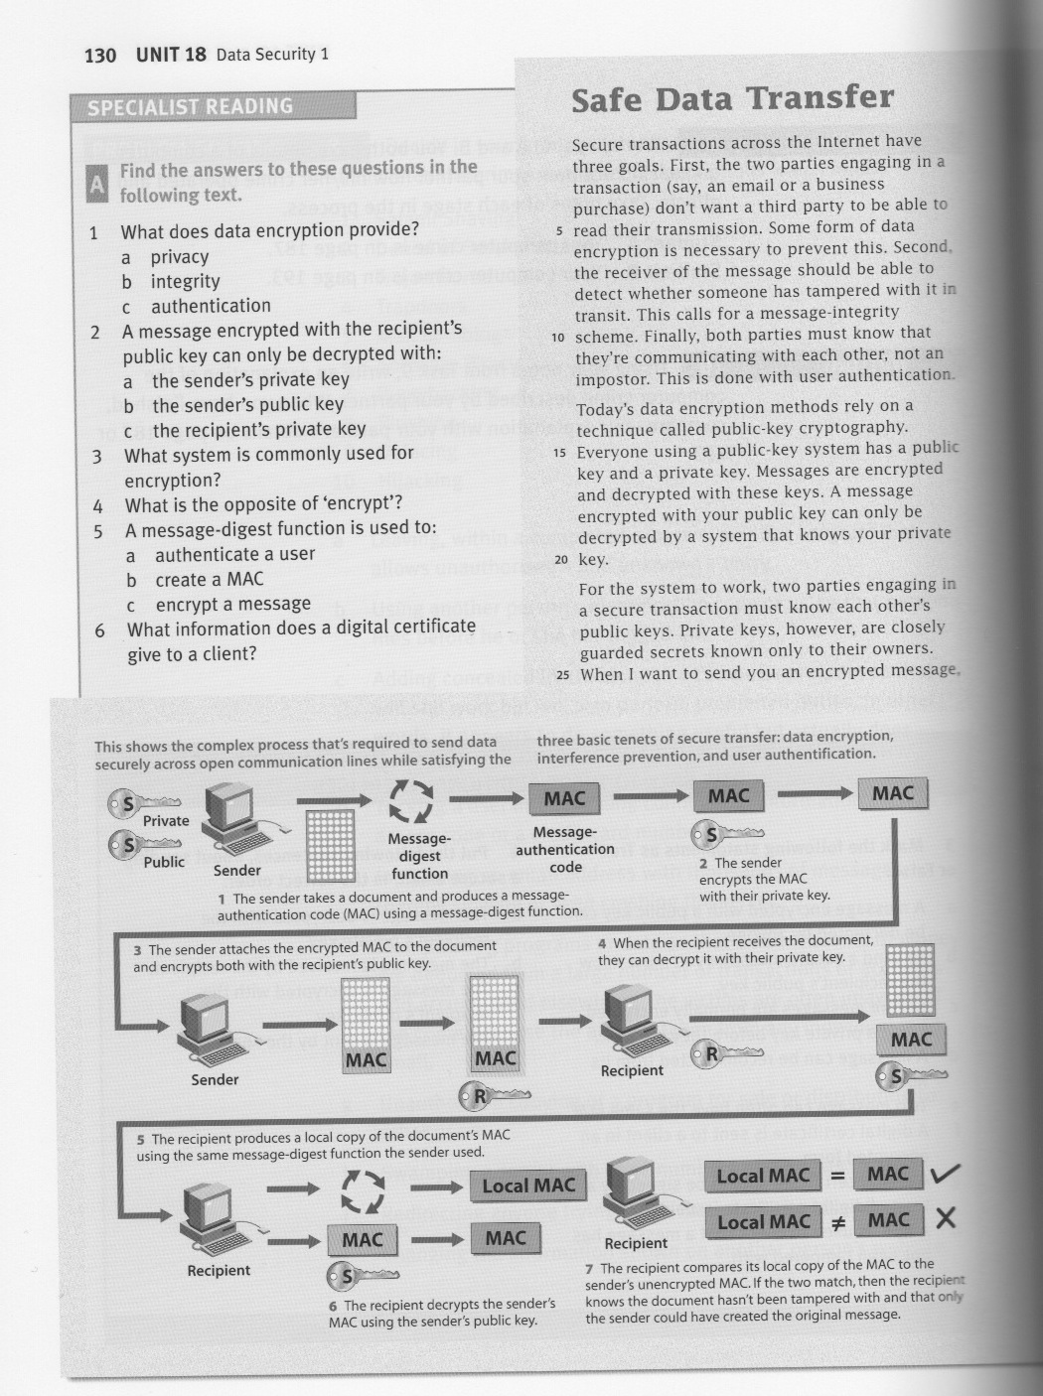

## 

## Writing- Forum Posts

1. Lend a helping hand! Here is a list of possible forum posts related to security issues. Write a useful response to help solve the problem.
   1. I think I got hacked. My connection log shows activity during the last weekend, while I was away. What do I risk? What should I do?
   2. I think I got malware on my computer. How can I be sure? What should I do?
   3. My e-mail password got stolen and changed. What do I risk and what can I do?
   4. I want to buy online, but I’m afraid my credit card information might get stolen. What do you recommend?
   5. I’m starting a business. My clients will save accounts on my website and be able to purchase online. What steps can I take to guarantee that their data is secure?

## Reading – Attackers Using New Technique To Bring Down Websites

1. Read the article. What do you think of the importance of this kind of attack?
2. Are there other such “new” techniques? What do you think is the most credible network security threat in the near future?
3. Imagine you are in charge of the security of a website’s servers, what steps do you take to ensure sufficient security?

## Video – How To Make An ATM Spew Out Money

1. Explain the two methods used by Barnaby Jack.
2. Are you surprised? Could such exploits be avoided? How?